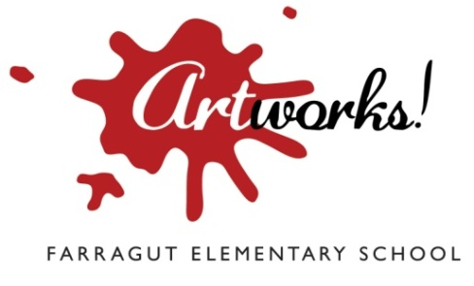
Supporting The Arts At Farragut

Farragut Fan Club
10820 Farragut Drive
Culver City, CA 90230
farragutschoolcommunity.org

Dear Sir or Madam,

Farragut Elementary is a public elementary school in Culver City, California. Our parent community believes in the value of arts education and our major annual fundraiser, Artworks!, has allowed us to provide extensive and high-quality arts education to our Kindergarten through 5th grade (K‐5) students in the face of steep budget cuts at state and local levels. We would appreciate deeply appreciate your support as a sponsor of Artworks! 2017 so we can make this year our most successful yet.

Increase Your Community Visibility Through Sponsorship
There are three Artworks! events where your contribution will be highlighted:

      - Artworks! Community Arts Day at Farragut, Saturday, April 15, 2017 (11 am – 4 pm): Families from throughout Culver City bring their children to Farragut for a joyous day celebrating the visual and performing arts through workshops, performances, art happenings and more. More than 700 people attended last year’s event. We expect that number to continue growing as a result of the increased awareness of this great – free! – family day.
      - Artworks! Online Auction, April 15-23, 2017: Last year we offered more than 350 items and services through our “Bidding Owl” site to bidders both local and across the country. More than 1,000 people checked out our auction site last year – and “checked out” with great vacations, gift cards, summer camps, art and more. Now a core part of our fundraising program, we expect our web traffic to increase this year.
      - Artworks! Fiesta On The Hill, Saturday evening, April 22, 2017: Held at gorgeous Baldwin Hills Scenic Overlook in Culver City, this Fiesta-themed evening event will include silent and live auctions, food, fun and music. More than 200 people attended last year’s event representing many of Southern California’s top employers.

Last year, with the help of businesses like yours, we raised enough to retain a part‐time Artist‐ in‐Residence to teach bi‐weekly art classes to children in all grades. We continued offering music programming that meets the second level of California’s Visual Arts & Performing Arts Standards. Working with organizations such as Drama Education Network, Symphonic Jazz Orchestra, We Tell Stories, Story Pirates and the 24th Street Theatre, we made drama, dance, music and art a part of the daily life of nearly 600 children.

Next Steps
Please complete the enclosed sponsorship form and return it with your donation to our booster club, the Farragut Fan club, at the address above. If you wish to contact us, please email either erdavidson112@yahoo.com or deannan@ca.rr.com.
Keep the arts alive ‐ help make Artworks! 2017 our most successful fundraiser yet!

Thank you for your consideration,
Ellen Davidson & Deanna Newell, Co- Presidents, Farragut Fan Club
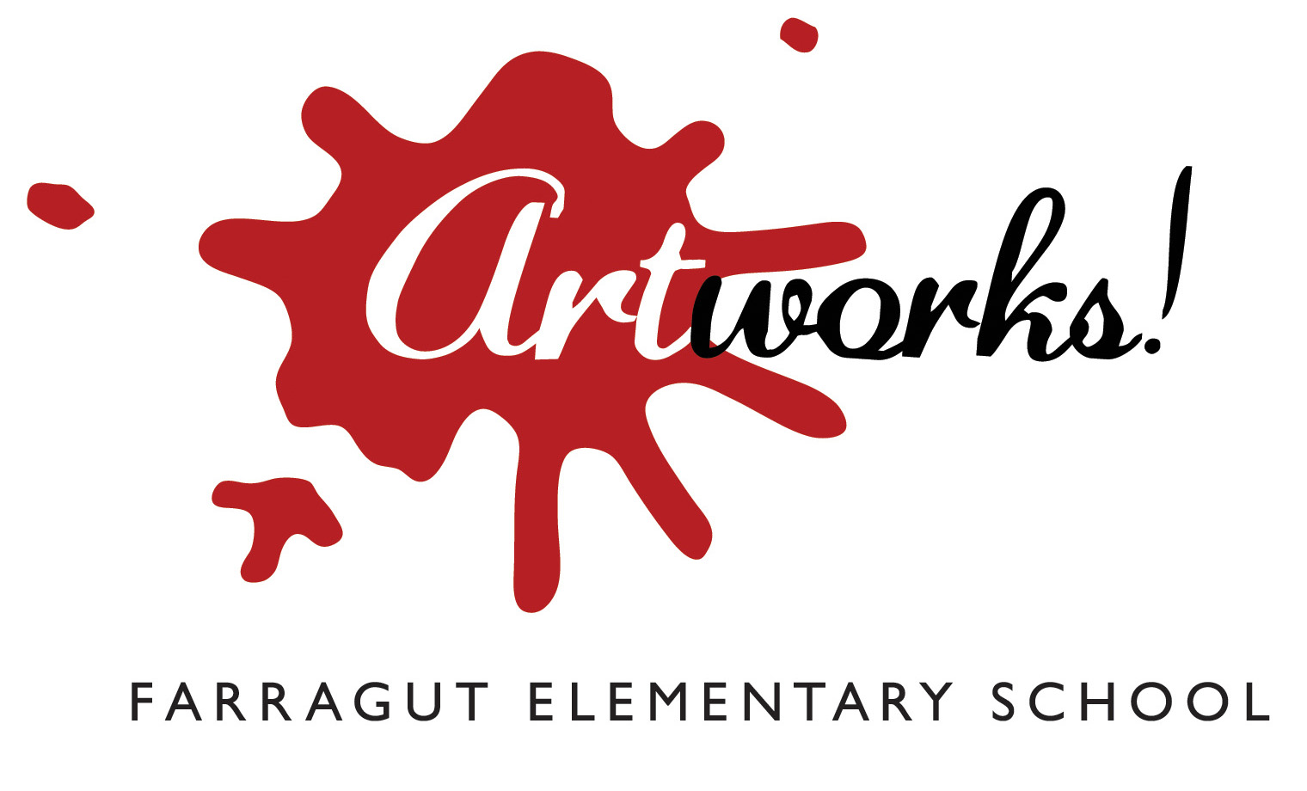
Artworks! 2017 Sponsorship Levels and Benefits
Sponsorship forms must be received by March 17, 2017

Platinum: | $5,000.00 and above or In-kind Contribution of equal or greater value  - Prominent placement of your company’s logo with a clickable link to your website on the Artworks! page located on the Farragut Fan Club’s website (farragutschoolcommunity.org).  - Your company’s logo with a clickable link to your website on every page of the Artworks! Bidding Owl auction page  - Your company’s logo placed on event invitations, posters and sponsorship signage.  - Six (6) complimentary event tickets to the Artworks! adult evening event on April 22, 2017. Also included are six (6) raffle tickets for special items offered at the event.  - Placement of your company’s literature/brochures at our “Thank you Sponsors!” table at the Artworks! events.
Gold: | $1,500.00 to $4,999.00 or In-kind Contribution of equal value  - Prominent listing of your company’s name with a clickable link to your website on the Artworks! page located on the Farragut Fan Club’s website (farragutschoolcommunity.org).  - Your company’s logo with a clickable link to your website on every page of the Artworks! Bidding Owl auction page  - Recognition of your company on event posters and sponsorship signage.  - Four (4) complimentary event tickets to the Artworks! adult evening event on April 16, 2016. Also included are four (4) raffle tickets for special items offered at the event.  - Placement of your company’s literature/brochures at our “Thank you Sponsors!” table at the Artworks! events.
Silver: | $500.00-$1,499.00 or In-kind Contribution of equal value  - Listing of your company’s name with a clickable link to your website on the Artworks! page located on the Farragut Fan Club’s website (farragutschoolcommunity.org).  - Your company’s logo with a clickable link to your website on every page of the Artworks! Bidding Owl auction page  - Two (2) complimentary event tickets to the Artworks! adult evening event on April 16, 2016. Also included are two (2) raffle tickets for special items offered at the event.  - Recognition of your company on event posters and sponsorship signage.  - Placement of your company’s literature/brochures at our “Thank you Sponsors!” table at the Artworks! events.
Bronze: | $100.00-$499.00 or In-kind Contribution of equal value  - Listing of your company’s name with a clickable link to your website on the Artworks! page located on the Farragut Fan Club’s website (farragutschoolcommunity.org).  - Recognition of your company on sponsorship signage.  - Placement of your company’s literature/brochures at our “Thank you Sponsors!” table at the Artworks! events.

Artworks! Sponsorship Commitment Form
FORM DEADLINE: MARCH 17, 2017
Platinum: $5,000.00 and above or In-kind Contribution of equal or greater value
Gold: $1,500.00 to $4,999.00 or In-kind Contribution of equal value
Silver: $500.00-$1,499.00 or In-kind Contribution of equal value
Bronze: $100.00-$499.00 or In-kind Contribution of equal value
Please accept my:
In-kind donation of:
Estimated Value: $
Payment of $ By Check (Payable to Farragut Fan Club)
Visa Master Card
Card No: Exp. Date
CVV2 Code Billing Zip Code
Signature Date
Company Name
Contact Name
Address
City, State, Zip
Phone Email
Name of Company/Family as you would like it to appear in promotional materials:

Web address for sponsor link
For Platinum, Gold and Silver Sponsors, please e-mail your logo artwork to anniefrederick@yahoo.com
Please return this form with your tax-deductible donation to:
Farragut Fan Club (Artworks!)
10820 Farragut Drive
Culver City, CA 90230
Attn: Ellen Davidson Farragut Fan Club Tax I.D. 95-4486978

